Understanding Our GSI Pipeline
What each piece does, and how they fit together

Why I am writing this
Sujato was worried that gradient starvation "breaks" the assumptions behind one of our main tools (DMFT), and separately there was some mixing-up of what our indices are for and what DMFT is for. Those are both natural confusions, and clearing them up is worth a short note. Read this before doing more work on the proof phase. It will save you from heading down a wrong path.
I have kept this in plain language and added a few simple diagrams. Nothing here is advanced; it is all about getting the roles of each piece straight.

1. The one distinction that matters most: neurons versus features
This is the single most important idea in the whole project, and getting it wrong leads to a lot of wasted effort. There are two different levels in a neural network, and gradient starvation lives at only one of them.
- A neuron (a unit) is one individual hidden unit. It is a microscopic piece of the network.
- A feature is a pattern that is spread across many neurons at once. It is a collective, macroscopic thing. In the original gradient starvation paper, a "feature" is one of these spread-out directions, and each one has a "strength" attached to it.
Here is the picture to hold in your head:
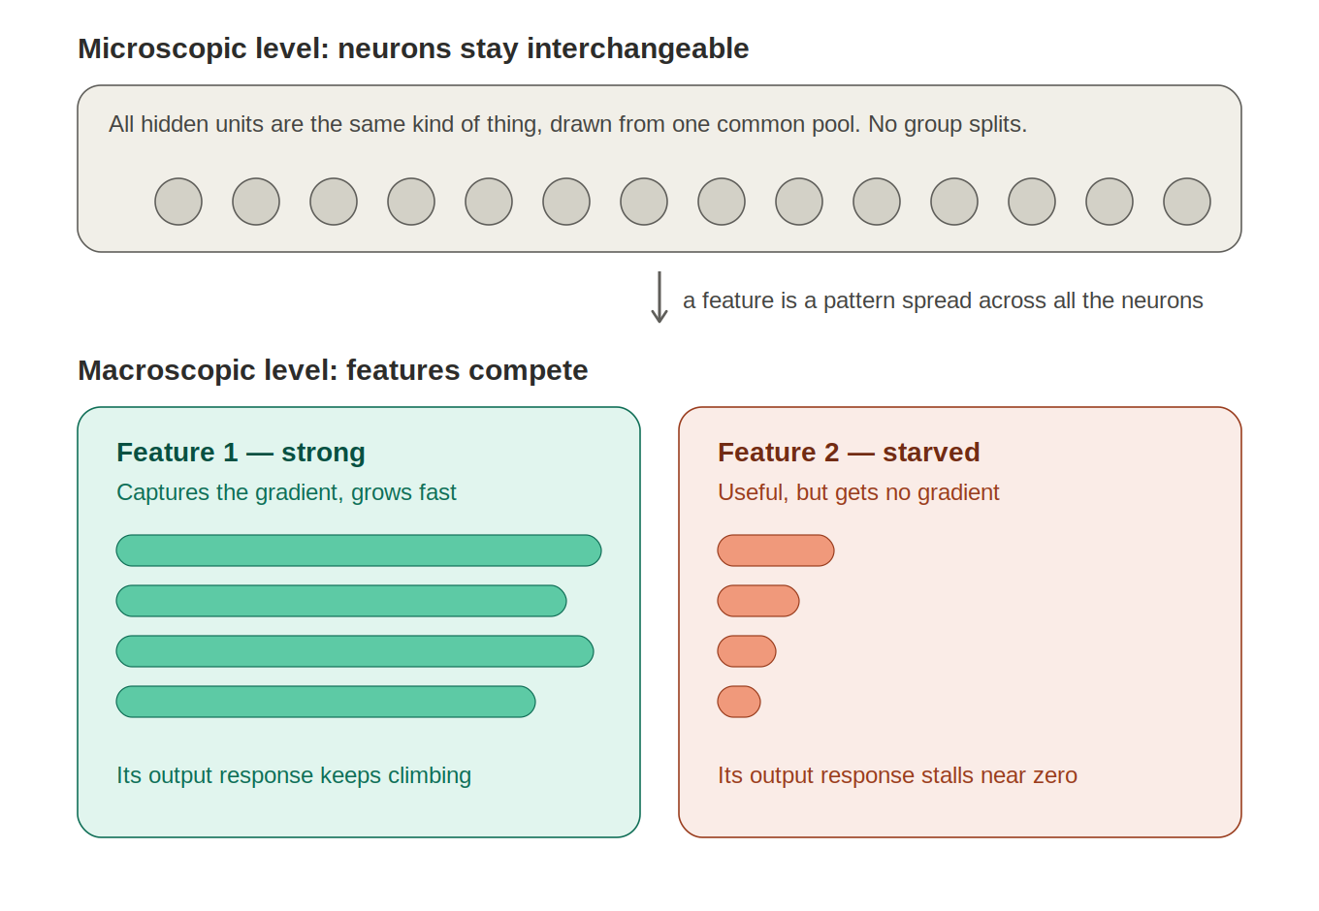
Figure 1. Gradient starvation happens between features (bottom), not between neurons (top).
The top row is the point people miss. The individual neurons stay interchangeable the whole time. They are all the same kind of object, drawn from one common pool. They do not split into a "strong neurons" group and a "weak neurons" group.
The bottom row is where gradient starvation actually happens. Two features, each built out of all the neurons together, compete for the gradient signal. The stronger feature grabs the signal and its output response grows, while the weaker but still useful feature is left with almost no gradient and stalls. That is starvation. It is a competition between collective patterns, not between individual units.
Why this matters for our tools. The concern was that starvation makes the neurons split into distinguishable groups, and that this breaks the assumption DMFT needs (that units are interchangeable). But as the top row shows, the units do not split. Starvation is a feature-level effect, and DMFT tracks exactly these feature-level objects (the kernel and its patterns). So the worry, while a very reasonable thing to check, does not actually apply. DMFT can see feature competition without any neuron ever leaving the common pool.
One more correction on that same point. DMFT does not "track one typical neuron that stands in for all the others." It tracks the whole spread of neuron behaviours, and in the interesting regime that spread is lopsided and not a simple bell curve. So even if the neurons did behave in a genuinely varied way, that variety is already inside what DMFT describes. The obstacle that was raised is not the real obstacle.

2. The three stages of the project, and which tool belongs where
The second confusion was about what our indices do versus what DMFT does. The cleanest way to see it is that our project has three separate stages, and each one uses a different tool. They do not overlap.
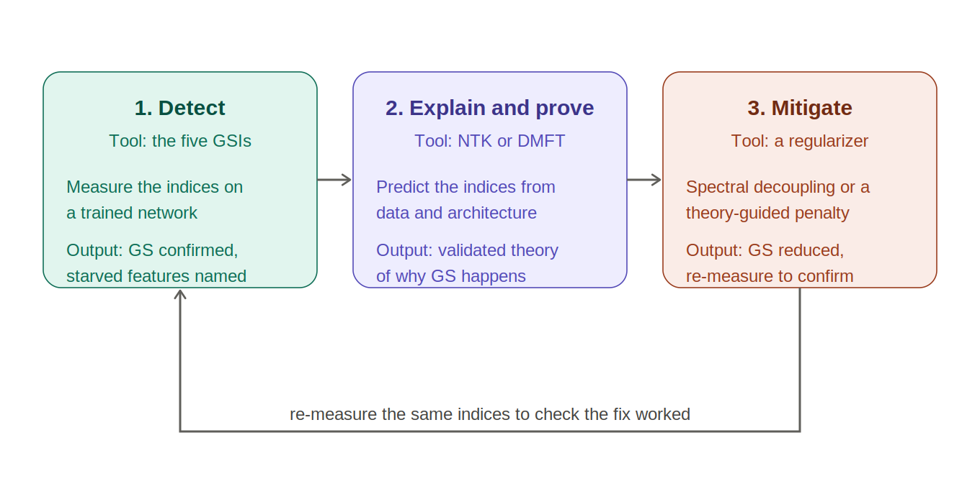
Figure 2. Three stages. The indices measure, DMFT explains and proves, and a separate regularizer fixes.

Stage 1: Detect
Here we use our five indices (the GSIs). We train a network, measure the indices on it, and use them to say "yes, gradient starvation is happening here, and these are the features being starved." This is purely a measurement job. This is the phase we have already finished.

Stage 2: Explain and prove
Here we use theory: NTK for the simple frozen-feature picture, and DMFT for the harder, more realistic picture where features actually change during training. The job of this stage is to explain, from the data and the architecture, why starvation happens, and to turn that explanation into a proof. This is the phase we are working on now, and it is where any real novelty for a top conference comes from.

Stage 3: Mitigate
Here we use a separate intervention, a regularizer, to actually reduce starvation. Spectral Decoupling from the original paper is one such fix; a new or better one could be another. Then we measure the same five indices again to check the fix worked.
The correction to keep in mind. DMFT and NTK do not "overcome" or "cure" gradient starvation. They are the microscope, not the medicine. They explain and predict the problem, and a good theory can guide us toward a better fix, but the fix itself is always a separate regularizer in Stage 3. If you ever find yourself saying "we will use DMFT to remove starvation," stop and re-read this paragraph.
Notice that the indices show up in Stage 1 and again in Stage 3. They are our measuring instrument throughout. DMFT appears only in Stage 2. The fix appears only in Stage 3.

3. What "predicted" and "measured" indices mean
Inside Stage 2 there is a small pipeline that caused some confusion, so let me spell it out. The five indices can be obtained in two different ways, and it is worth being clear about which is which.
- Measured indices. You train a real network and compute the five indices from that actual run. These are real numbers that come out of a real training trajectory.
- Predicted indices. You have a theory (DMFT), and the theory tells you what those same five indices should be over training time, worked out from the data and architecture without running the full network. These are the theory's forecasts.
The reason we bother producing both is to check the theory. If the predicted indices match the measured ones, the theory is correct and we can trust it. Here is that Stage 2 pipeline drawn out:
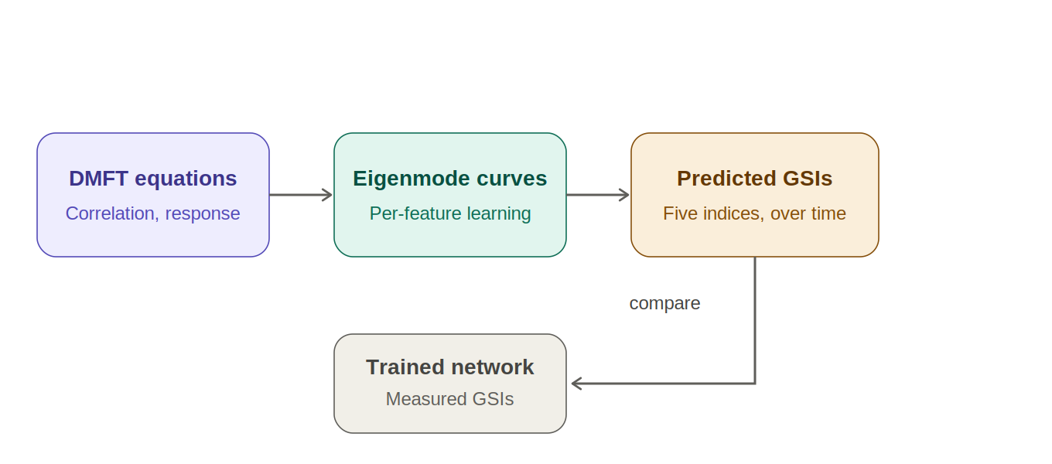
Figure 3. The Stage 2 pipeline. The last arrow is a comparison, not a fix.
Reading it left to right:
- DMFT equations. You write down the self-consistent equations (a correlation function and a response function) for our setting. This is where the theory starts.
- Eigenmode curves. You break the resulting feature kernel into its separate patterns and get, for each one, a learning curve over training time. Starvation shows up here as one pattern's curve climbing while another useful one stays flat.
- Predicted indices. From those curves you compute what our five indices should read at each moment in training. These are the theory's forecasts.
- Compare to the trained network. You train the real network, measure the five indices, and check whether they match the forecast. Agreement means the theory is right.
Read the last arrow carefully. The arrow pointing to the trained network is a comparison, not a fix. The trained network is the ground truth we check the theory against. DMFT is not doing anything to the network here; it is being tested against it. Once the theory passes this test, it becomes the backbone of our proof, and only later does it help us design a fix in Stage 3.

4. Where the real difficulty is
I want you to know where the genuine hard part sits, because it is not the exchangeability worry from Section 1. The real difficulty is this:
- For a linear network, the predicted-versus-measured matching can be worked out cleanly, and this is the place where a real, rigorous proof is within reach. Start here.
- For a nonlinear network, the DMFT equations have no clean closed-form answer. You solve them with a numerical loop and match the result to the measured indices. That means the honest claim becomes "exact in the DMFT limit, plus numerical agreement," not "a full theorem for every nonlinear network." Say this plainly whenever you write it up.
So a fully worked nonlinear DMFT derivation with the label "gradient starvation" on it does not yet exist in the literature. The pieces exist, but assembling them is real work, and that is exactly why it is worth doing.

5. Common misunderstandings to avoid
Keep this short list somewhere visible.
- Gradient starvation is competition between features, not between neurons. The neurons stay interchangeable.
- DMFT does not track one typical neuron; it tracks the whole spread of neuron behaviour.
- DMFT and NTK explain and predict starvation. They do not cure it. The cure is a separate regularizer.
- "Predicted" and "measured" indices are the same five indices obtained two ways. Comparing them tests the theory.
- The clean, rigorous case is the linear network. The nonlinear case is numerical plus exact-in-the-limit, and we should never oversell it.

Where to start
If you are picking this up fresh, do two things first. Read the original gradient starvation paper until Figure 1 and its main theorem make sense to you at the feature level. Then set up the linear-network case of the Stage 2 pipeline and get the predicted indices to match a real linear network. Once that agreement is in hand, you have a solid base to build the harder nonlinear and recurrent cases on. Do not rush past the linear case; it is where the whole thing is anchored.

